* **Project Title:** A Gesture-based Tool for Sterile Browsing of Radiology Images  **Project Design Phase-I** - **Solution Fit Template Team ID:** PNT2022TMID17578

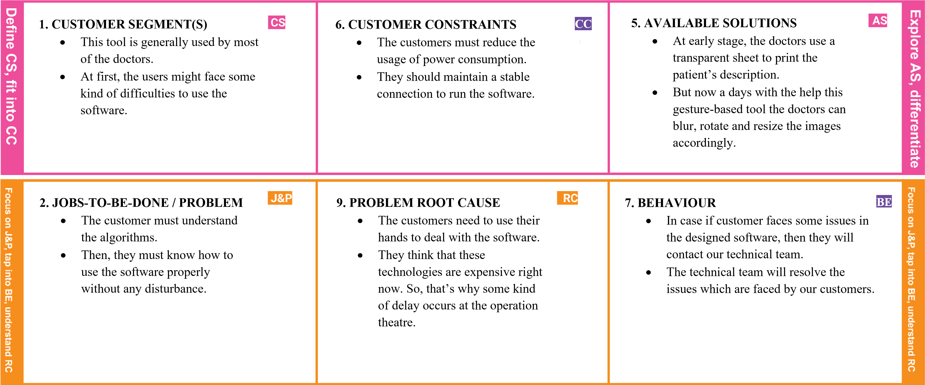

|  |  |  |  |  |  |  |  |
| --- | --- | --- | --- | --- | --- | --- | --- |
|  | **3. TRIGGERS**  When it’s installed at place, then the customers show some eagerness to install at their place to use the software. | **TR** | **10. YOUR SOLUTION**   * When this kind of technology launch at worldwide, then it will be helpful to the doctors to do their surgeries in quick and easier way. * The Gesture-based tool is completely based on the hand moment and it act accordingly to its trained datasets. | **SL** | **8. CHANNELS of BEHAVIOR**   * Online:   Extracts channels from behavior block.   * Offline:   Extracts channels from behavior block and is used for customer’s deployment. | **CH** |  |
| **4. EMOTIONS: BEFORE / AFTER**   * Sometimes doctors felt sad because they need to carry the patient’s description at their place. * But now a days doctors uses the gesture tool to save their work. | **EM** |